**CODING CHALLENGE 5**

**EXECUTED BY**

**RAHUL S**

CREATE DATABASE VirtualArtGallery;

USE VirtualArtGallery ;

CREATE TABLE Artists (

ArtistID INT PRIMARY KEY,

Name VARCHAR(255) NOT NULL,

Biography TEXT,

Nationality VARCHAR(100));

CREATE TABLE Categories (

CategoryID INT PRIMARY KEY,

Name VARCHAR(100) NOT NULL);

CREATE TABLE Artworks (

ArtworkID INT PRIMARY KEY,

Title VARCHAR(255) NOT NULL,

ArtistID INT,

CategoryID INT,

Year INT,

Description TEXT,

ImageURL VARCHAR(255),

FOREIGN KEY (ArtistID) REFERENCES Artists (ArtistID),

FOREIGN KEY (CategoryID) REFERENCES Categories (CategoryID));

CREATE TABLE Exhibitions (

ExhibitionID INT PRIMARY KEY,

Title VARCHAR(255) NOT NULL,

StartDate DATE,

EndDate DATE,

Description TEXT);

CREATE TABLE ExhibitionArtworks (

ExhibitionID INT,

ArtworkID INT,

PRIMARY KEY (ExhibitionID, ArtworkID),

FOREIGN KEY (ExhibitionID) REFERENCES Exhibitions (ExhibitionID),

FOREIGN KEY (ArtworkID) REFERENCES Artworks (ArtworkID));

INSERT INTO Artists (ArtistID, Name, Biography, Nationality) VALUES

(1, 'Pablo Picasso', 'Renowned Spanish painter and sculptor.', 'Spanish'),

(2, 'Vincent van Gogh', 'Dutch post-impressionist painter.', 'Dutch'),

(3, 'Leonardo da Vinci', 'Italian polymath of the Renaissance.', 'Italian');

INSERT INTO Categories (CategoryID, Name) VALUES

(1, 'Painting'),

(2, 'Sculpture'),

(3, 'Photography');

INSERT INTO Artworks (ArtworkID, Title, ArtistID, CategoryID, Year, Description, ImageURL) VALUES

(1, 'Starry Night', 2, 1, 1889, 'A famous painting by Vincent van Gogh.', 'starry_night.jpg'),

(2, 'Mona Lisa', 3, 1, 1503, 'The iconic portrait by Leonardo da Vinci.', 'mona_lisa.jpg'),

(3, 'Guernica', 1, 1, 1937, 'Pablo Picasso\'s powerful anti-war mural.', 'guernica.jpg');

INSERT INTO Exhibitions (ExhibitionID, Title, StartDate, EndDate, Description) VALUES

(1, 'Modern Art Masterpieces', '2023-01-01', '2023-03-01', 'A collection of modern art masterpieces.'),

(2, 'Renaissance Art', '2023-04-01', '2023-06-01', 'A showcase of Renaissance art treasures.');

INSERT INTO ExhibitionArtworks (ExhibitionID, ArtworkID) VALUES

(1, 1),

(1, 2),

(1, 3),

(2, 2);

-- Q1

SELECT Name, COUNT(*) AS ArtworkCount

FROM Artists

JOIN Artworks ON Artists.ArtistID = Artworks.ArtistID

GROUP BY Name

ORDER BY ArtworkCount DESC;

-- Q2

SELECT Title

FROM Artworks

JOIN Artists ON Artworks.ArtistID = Artists.ArtistID

WHERE Nationality IN ('Spanish', 'Dutch')

ORDER BY Year ASC;

-- Q3

SELECT Artists.Name, COUNT(*) AS PaintingCount

FROM Artists

JOIN Artworks ON Artists.ArtistID = Artworks.ArtistID

JOIN Categories ON Artworks.CategoryID = Categories.CategoryID

WHERE Categories.Name = 'Painting'

GROUP BY Artists.Name;

-- Q4

SELECT Artworks.Title AS ArtworkTitle, Artists.Name AS ArtistName, Categories.Name AS CategoryName

FROM ExhibitionArtworks

JOIN Exhibitions ON ExhibitionArtworks.ExhibitionID = Exhibitions.ExhibitionID

JOIN Artworks ON ExhibitionArtworks.ArtworkID = Artworks.ArtworkID

JOIN Artists ON Artworks.ArtistID = Artists.ArtistID

JOIN Categories ON Artworks.CategoryID = Categories.CategoryID

WHERE Exhibitions.Title = 'Modern Art Masterpieces';

-- Q5

SELECT Artists.Name, COUNT(*) AS ArtworkCount

FROM Artists

JOIN Artworks ON Artists.ArtistID = Artworks.ArtistID

GROUP BY Artists.Name

HAVING COUNT(*) > 2;

-- Q6

SELECT A.Title

FROM Artworks A

JOIN ExhibitionArtworks EA1 ON A.ArtworkID = EA1.ArtworkID

JOIN Exhibitions E1 ON EA1.ExhibitionID = E1.ExhibitionID

JOIN ExhibitionArtworks EA2 ON A.ArtworkID = EA2.ArtworkID

JOIN Exhibitions E2 ON EA2.ExhibitionID = E2.ExhibitionID

WHERE E1.Title = 'Modern Art Masterpieces'

AND E2.Title = 'Renaissance Art';

-- Q7

SELECT Categories.Name AS CategoryName, COUNT(Artworks.ArtworkID) AS TotalArtworks

FROM Categories

LEFT JOIN Artworks ON Categories.CategoryID = Artworks.CategoryID

GROUP BY Categories.Name;

-- Q8

SELECT Artists.Name, COUNT(Artworks.ArtworkID) AS ArtworkCount

FROM Artists

JOIN Artworks ON Artists.ArtistID = Artworks.ArtistID

GROUP BY Artists.Name

HAVING COUNT(Artworks.ArtworkID) > 3;

-- Q9

SELECT Artworks.Title

FROM Artworks

JOIN Artists ON Artworks.ArtistID = Artists.ArtistID

WHERE Artists.Nationality = 'Spanish';

-- Q10

SELECT E.Title

FROM Exhibitions E

JOIN ExhibitionArtworks EA ON E.ExhibitionID = EA.ExhibitionID

JOIN Artworks A ON EA.ArtworkID = A.ArtworkID

WHERE A.ArtistID IN (

SELECT ArtistID FROM Artists WHERE Name IN ('Vincent van Gogh', 'Leonardo da Vinci')

)

GROUP BY E.Title

HAVING COUNT(DISTINCT A.ArtistID) = 2;

-- Q11

SELECT A.Title

FROM Artworks A

LEFT JOIN ExhibitionArtworks EA ON A.ArtworkID = EA.ArtworkID

WHERE EA.ExhibitionID IS NULL;

-- Q12

SELECT A.Name

FROM Artists A

JOIN Artworks AW ON A.ArtistID = AW.ArtistID

GROUP BY A.ArtistID, A.Name

HAVING COUNT(DISTINCT AW.CategoryID) = (SELECT COUNT(*) FROM Categories);

-- Q13

SELECT Categories.Name AS Category, COUNT(Artworks.ArtworkID) AS TotalArtworks

FROM Categories

LEFT JOIN Artworks ON Categories.CategoryID = Artworks.CategoryID

GROUP BY Categories.CategoryID, Categories.Name;

-- Q14

SELECT Artists.Name

FROM Artists

JOIN Artworks ON Artists.ArtistID = Artworks.ArtistID

GROUP BY Artists.ArtistID, Artists.Name

HAVING COUNT(Artworks.ArtworkID) > 2;

-- Q15

SELECT Categories.Name AS Category, AVG(Artworks.Year) AS AverageYear

FROM Categories

JOIN Artworks ON Categories.CategoryID = Artworks.CategoryID

GROUP BY Categories.CategoryID, Categories.Name

HAVING COUNT(Artworks.ArtworkID) > 1;

-- Q16

SELECT Artworks.Title

FROM Artworks

JOIN ExhibitionArtworks ON Artworks.ArtworkID = ExhibitionArtworks.ArtworkID

JOIN Exhibitions ON ExhibitionArtworks.ExhibitionID = Exhibitions.ExhibitionID

WHERE Exhibitions.Title = 'Modern Art Masterpieces';

-- Q17

SELECT Categories.Name AS Category, AVG(Artworks.Year) AS AverageYear

FROM Categories

JOIN Artworks ON Categories.CategoryID = Artworks.CategoryID

GROUP BY Categories.CategoryID, Categories.Name

HAVING AVG(Artworks.Year) > (

SELECT AVG(Year) FROM Artworks

);

-- Q18

SELECT Artworks.Title

FROM Artworks

LEFT JOIN ExhibitionArtworks ON Artworks.ArtworkID = ExhibitionArtworks.ArtworkID

WHERE ExhibitionArtworks.ExhibitionID IS NULL;

-- Q19

SELECT DISTINCT Artists.Name

FROM Artists

JOIN Artworks ON Artists.ArtistID = Artworks.ArtistID

WHERE Artworks.CategoryID = (

SELECT CategoryID

FROM Artworks

WHERE Title = 'Mona Lisa'

);

-- Q20

SELECT Artists.Name, COUNT(Artworks.ArtworkID) AS NumberOfArtworks

FROM Artists

JOIN Artworks ON Artists.ArtistID = Artworks.ArtistID

GROUP BY Artists.Name;

OUTPUTS

Q1

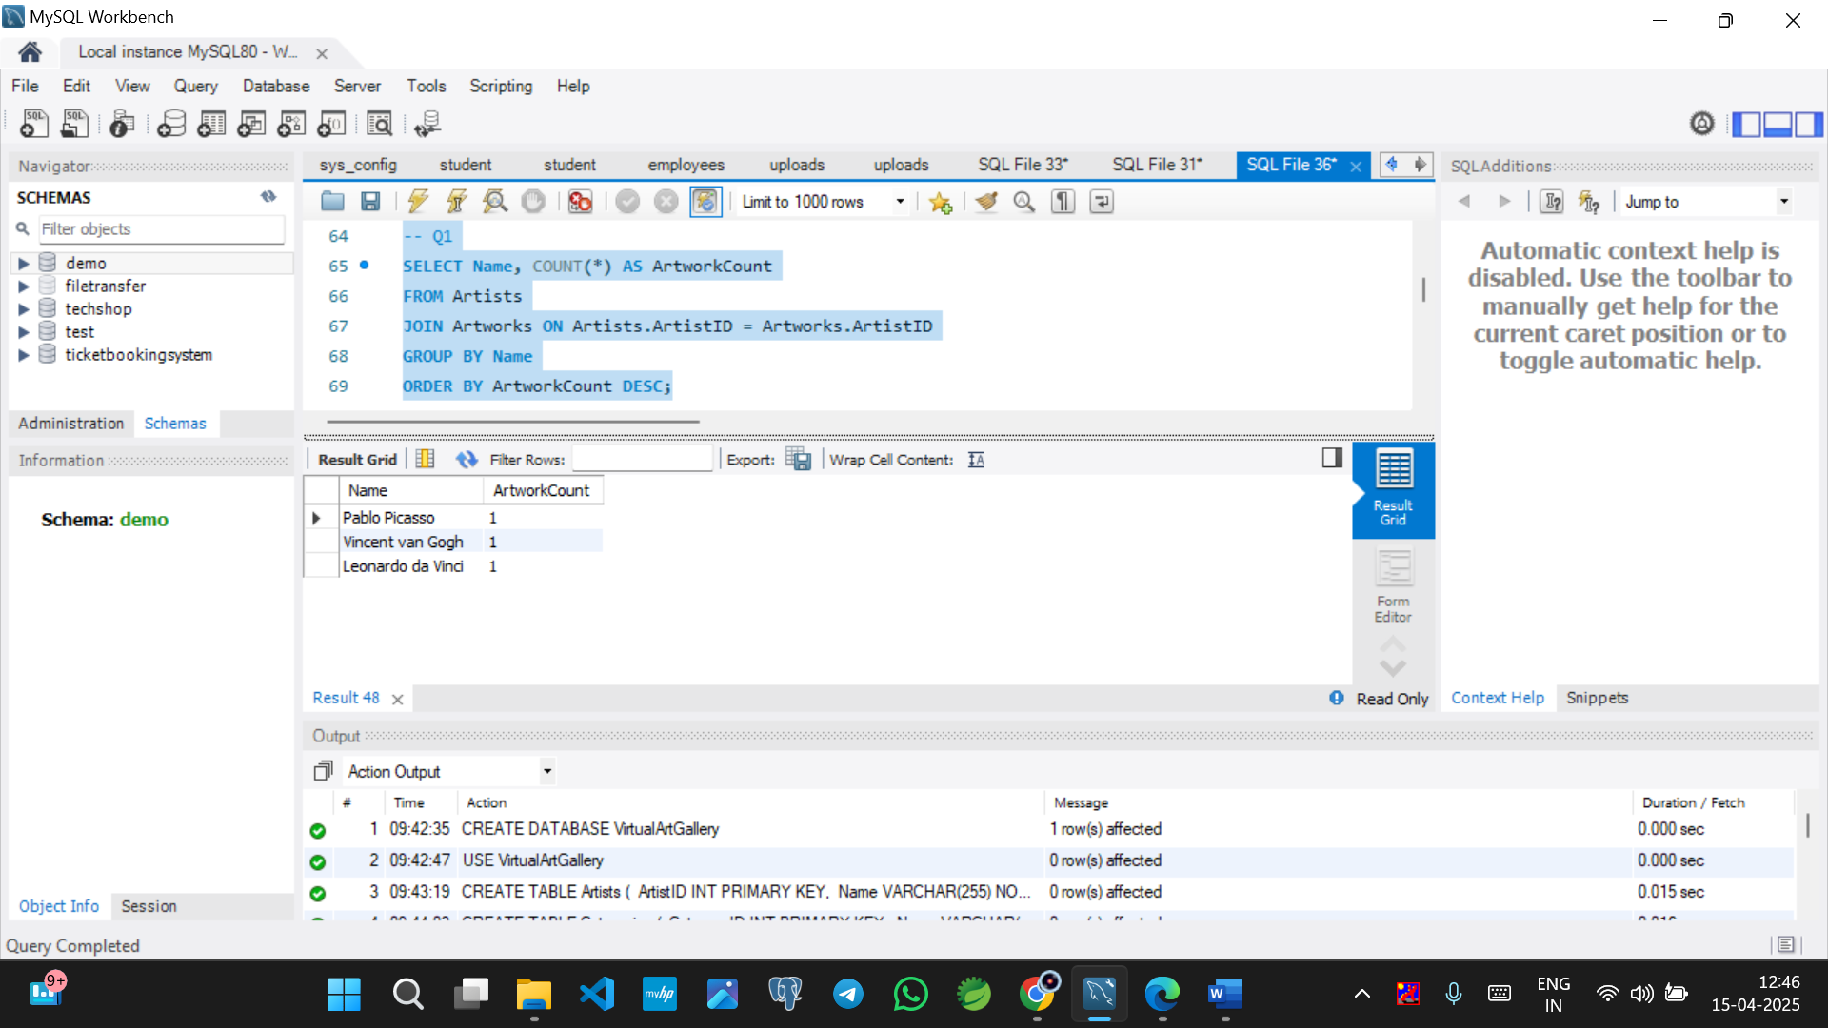

Q2

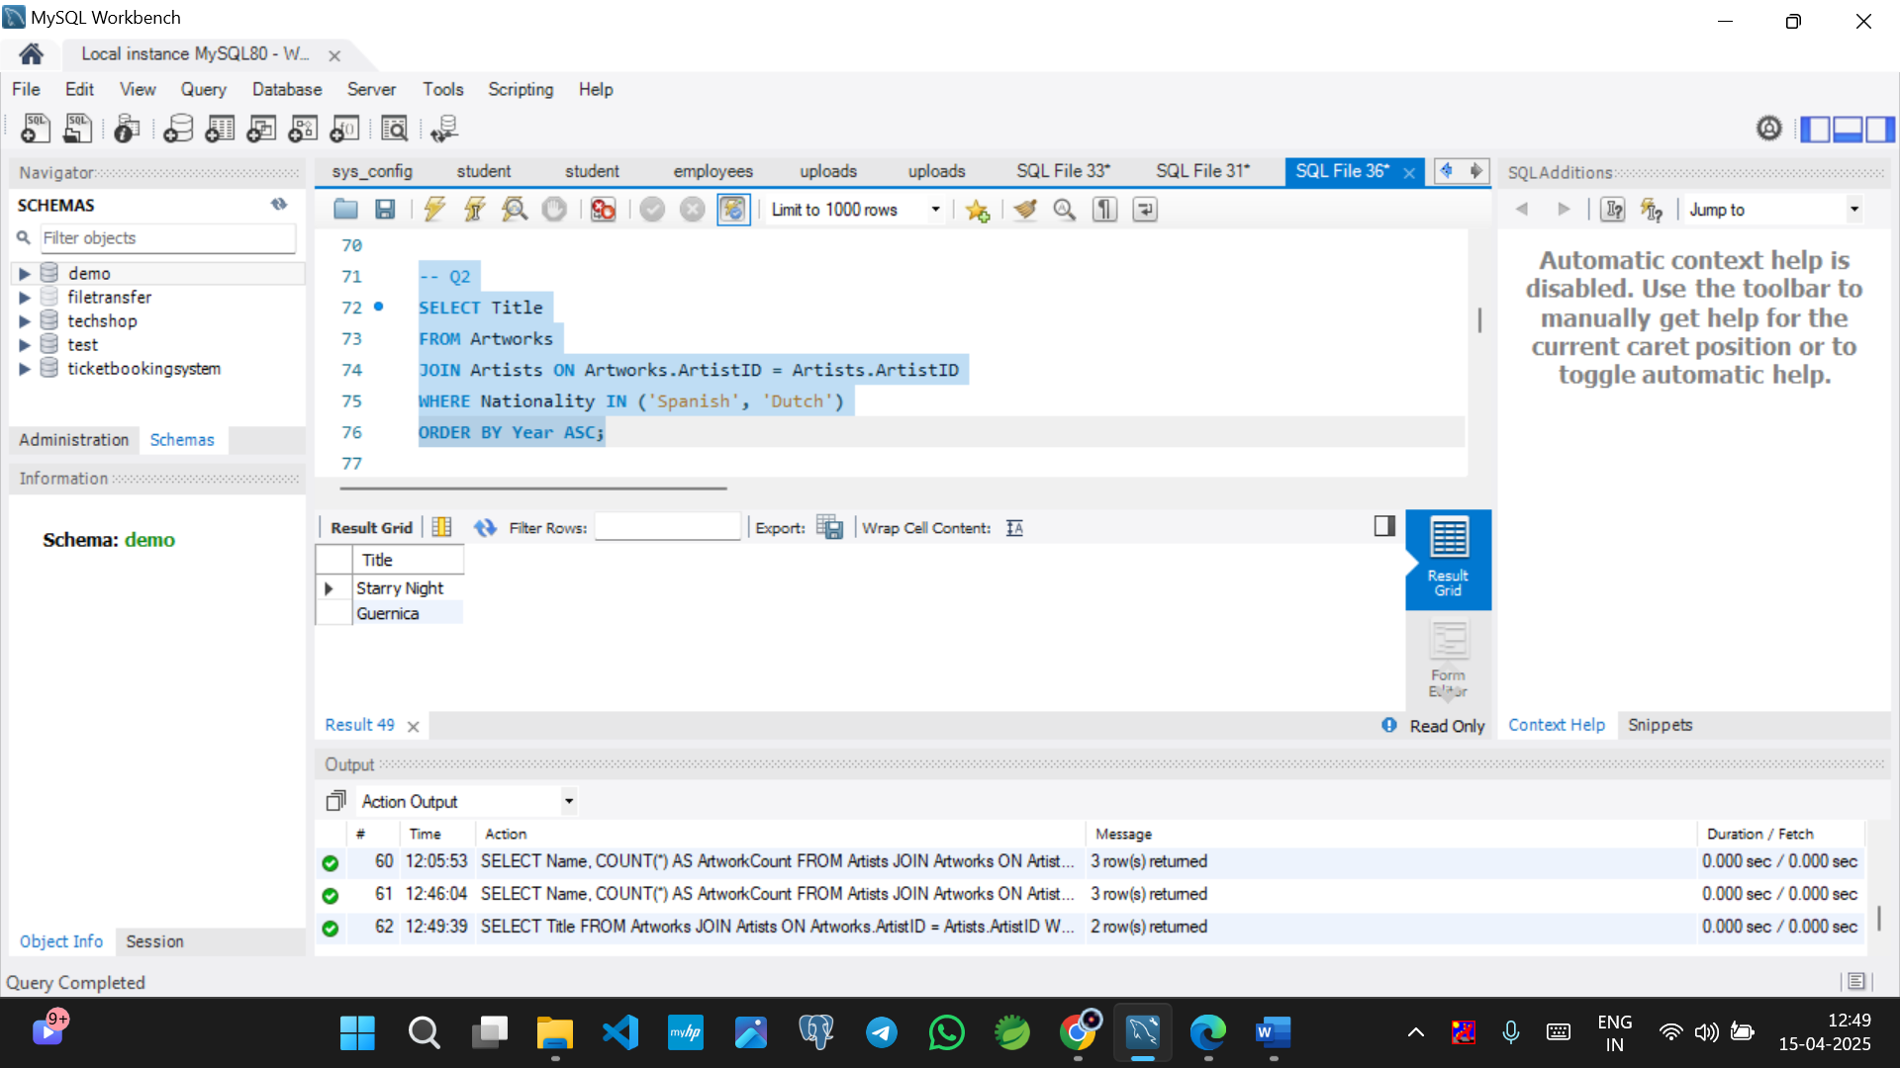

Q3

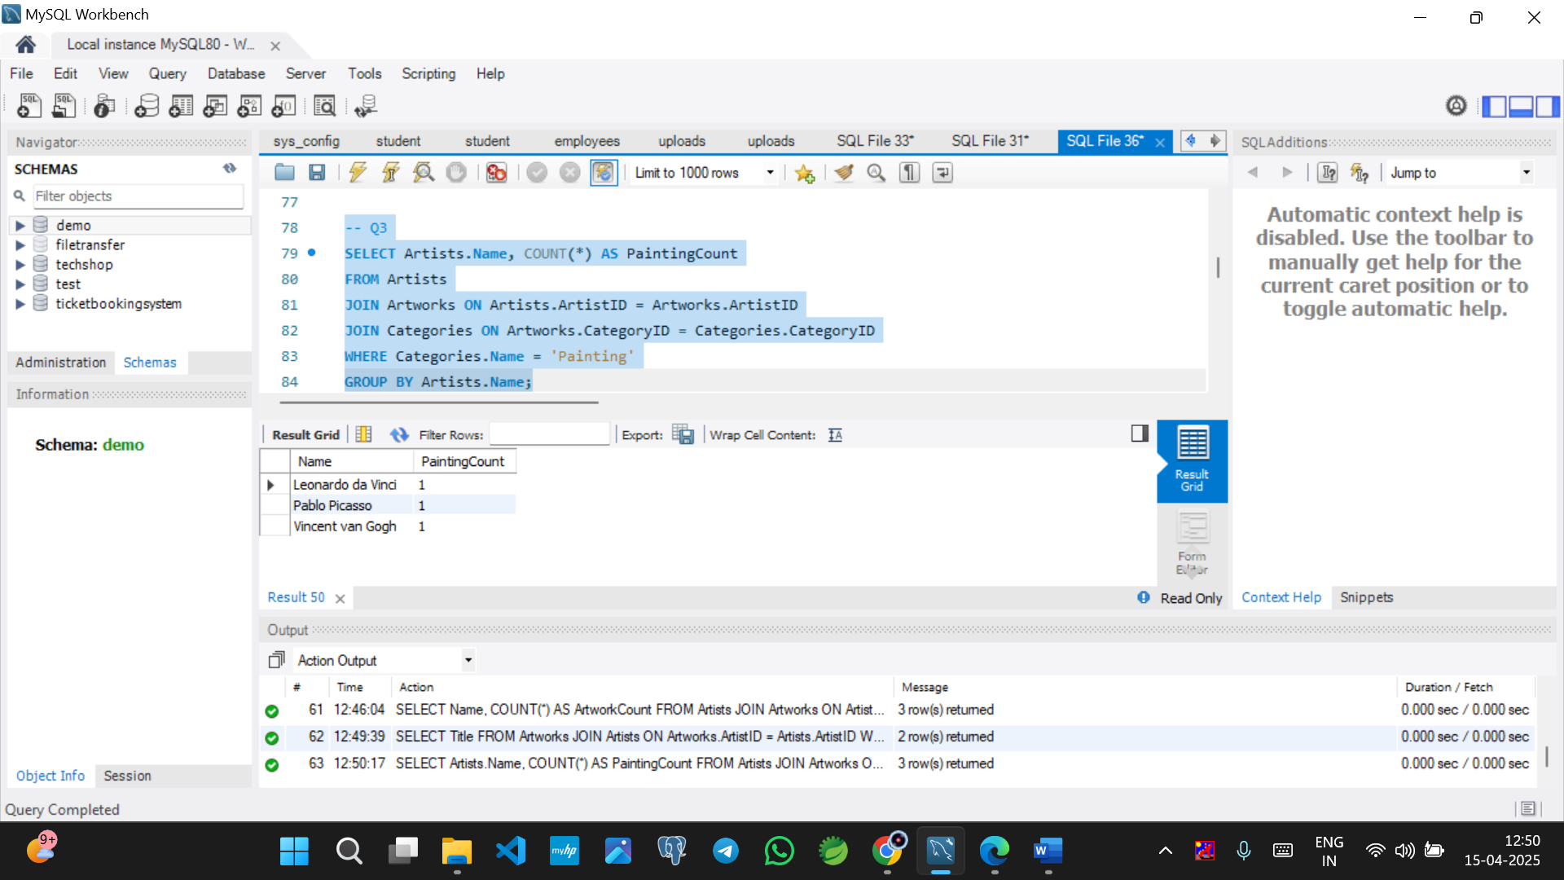

Q4

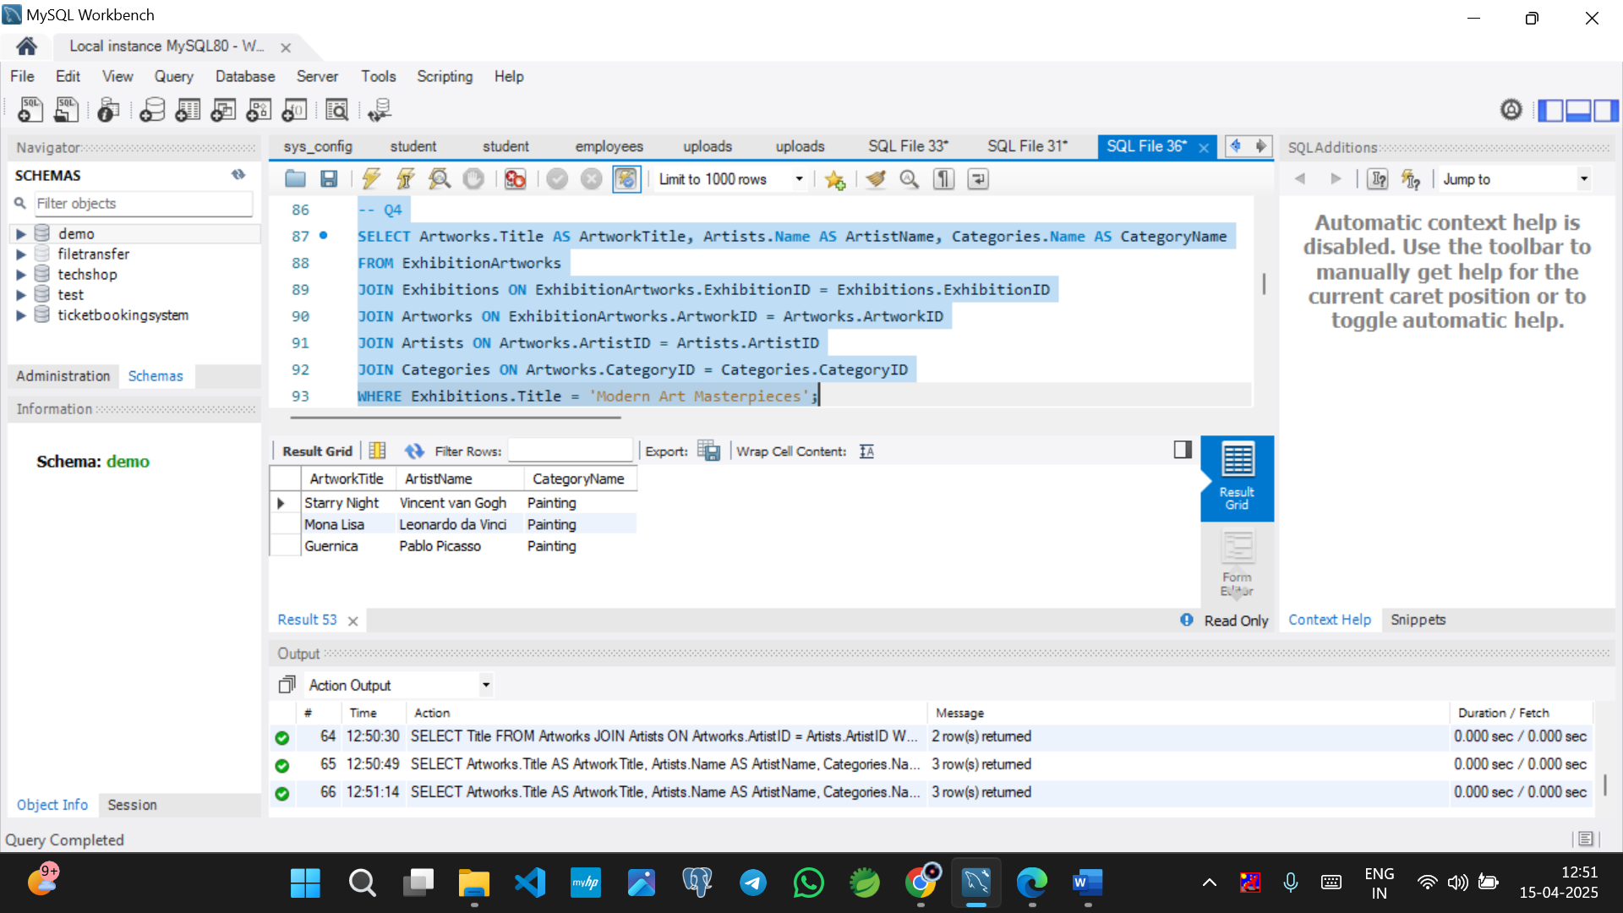

Q5

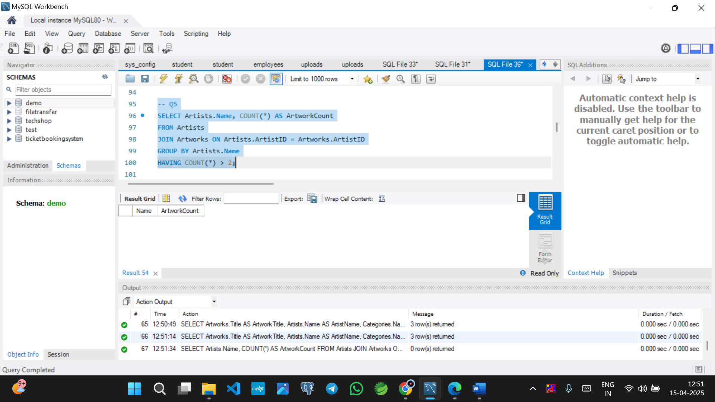

Q6

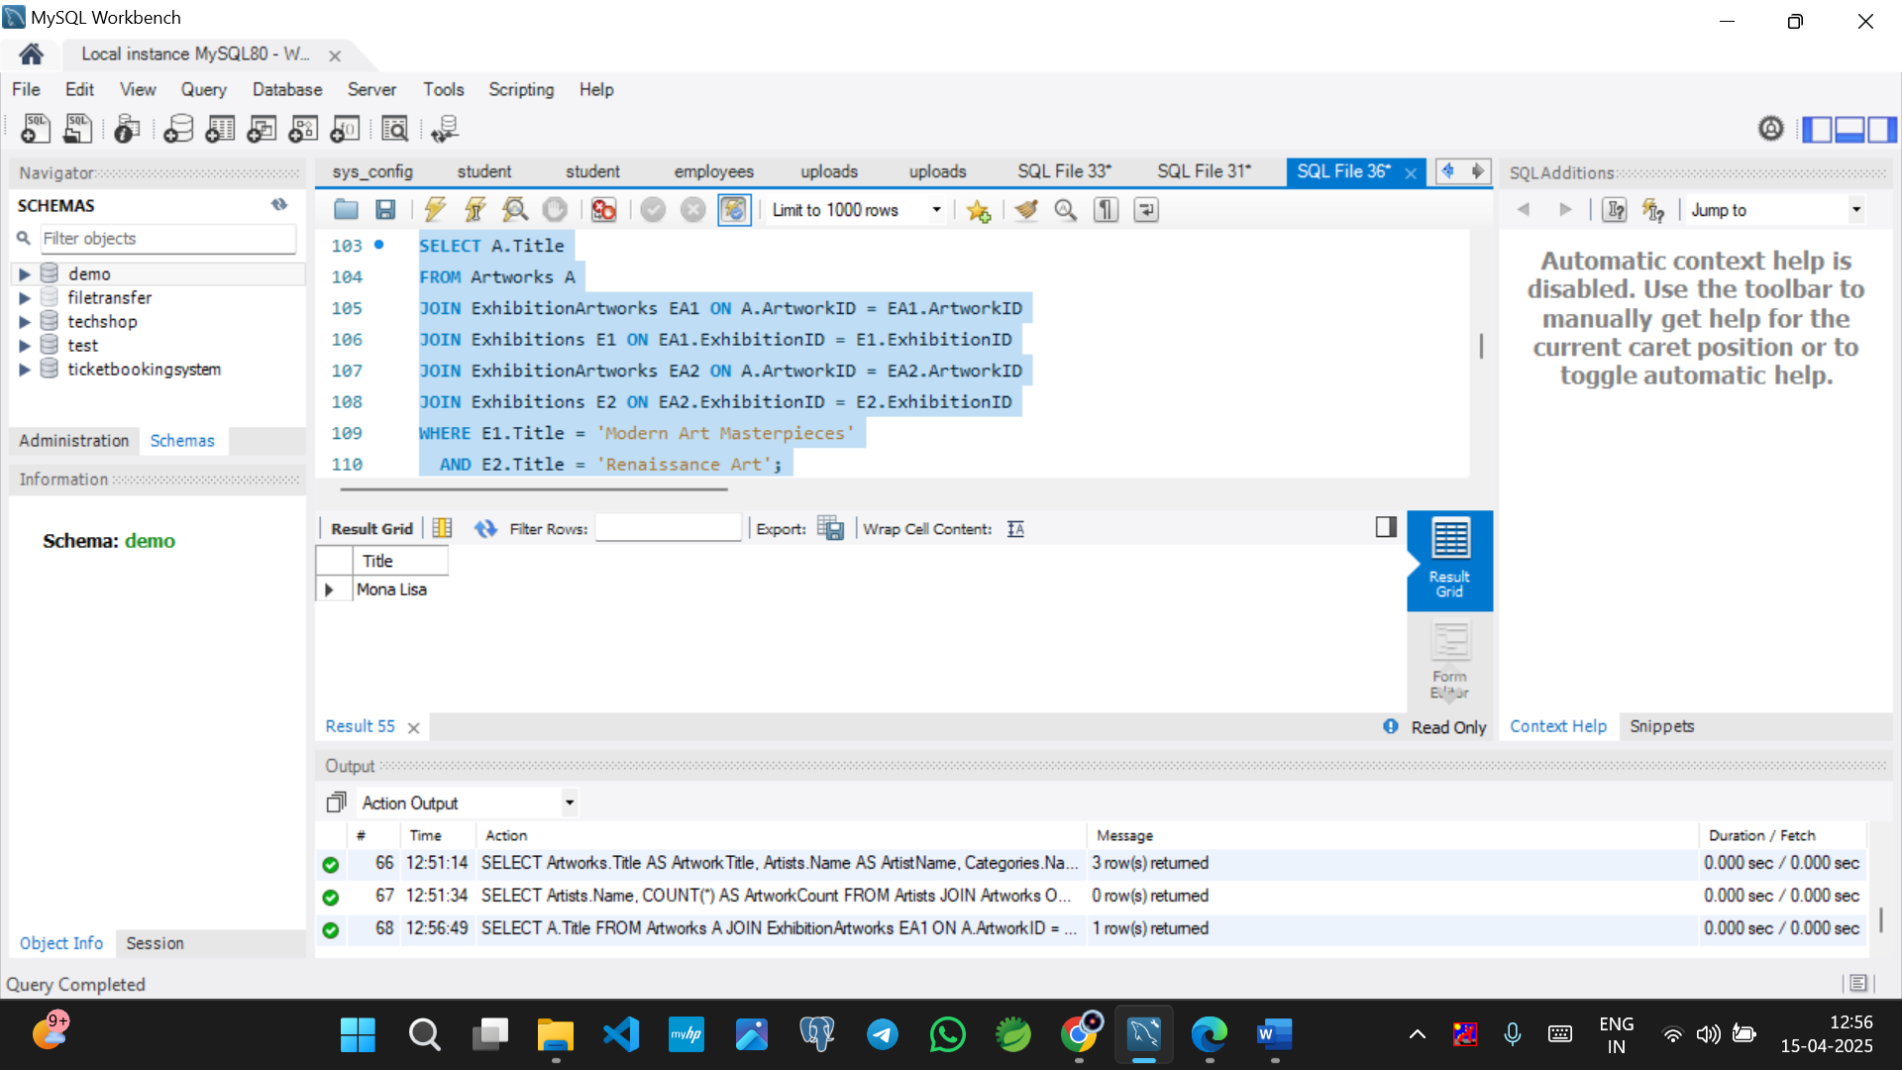

Q7

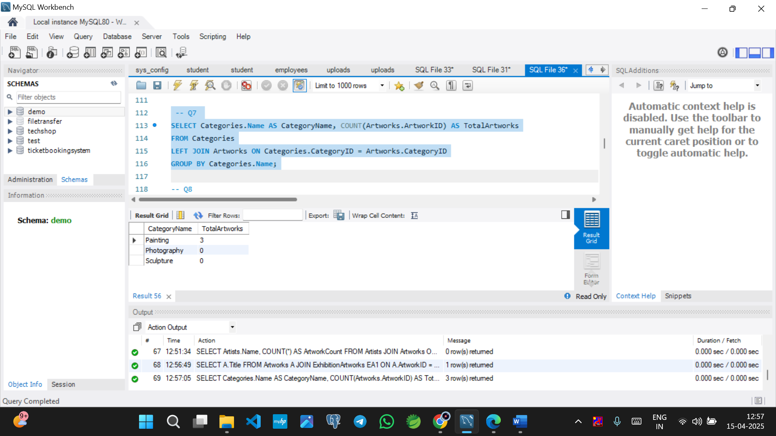

Q8

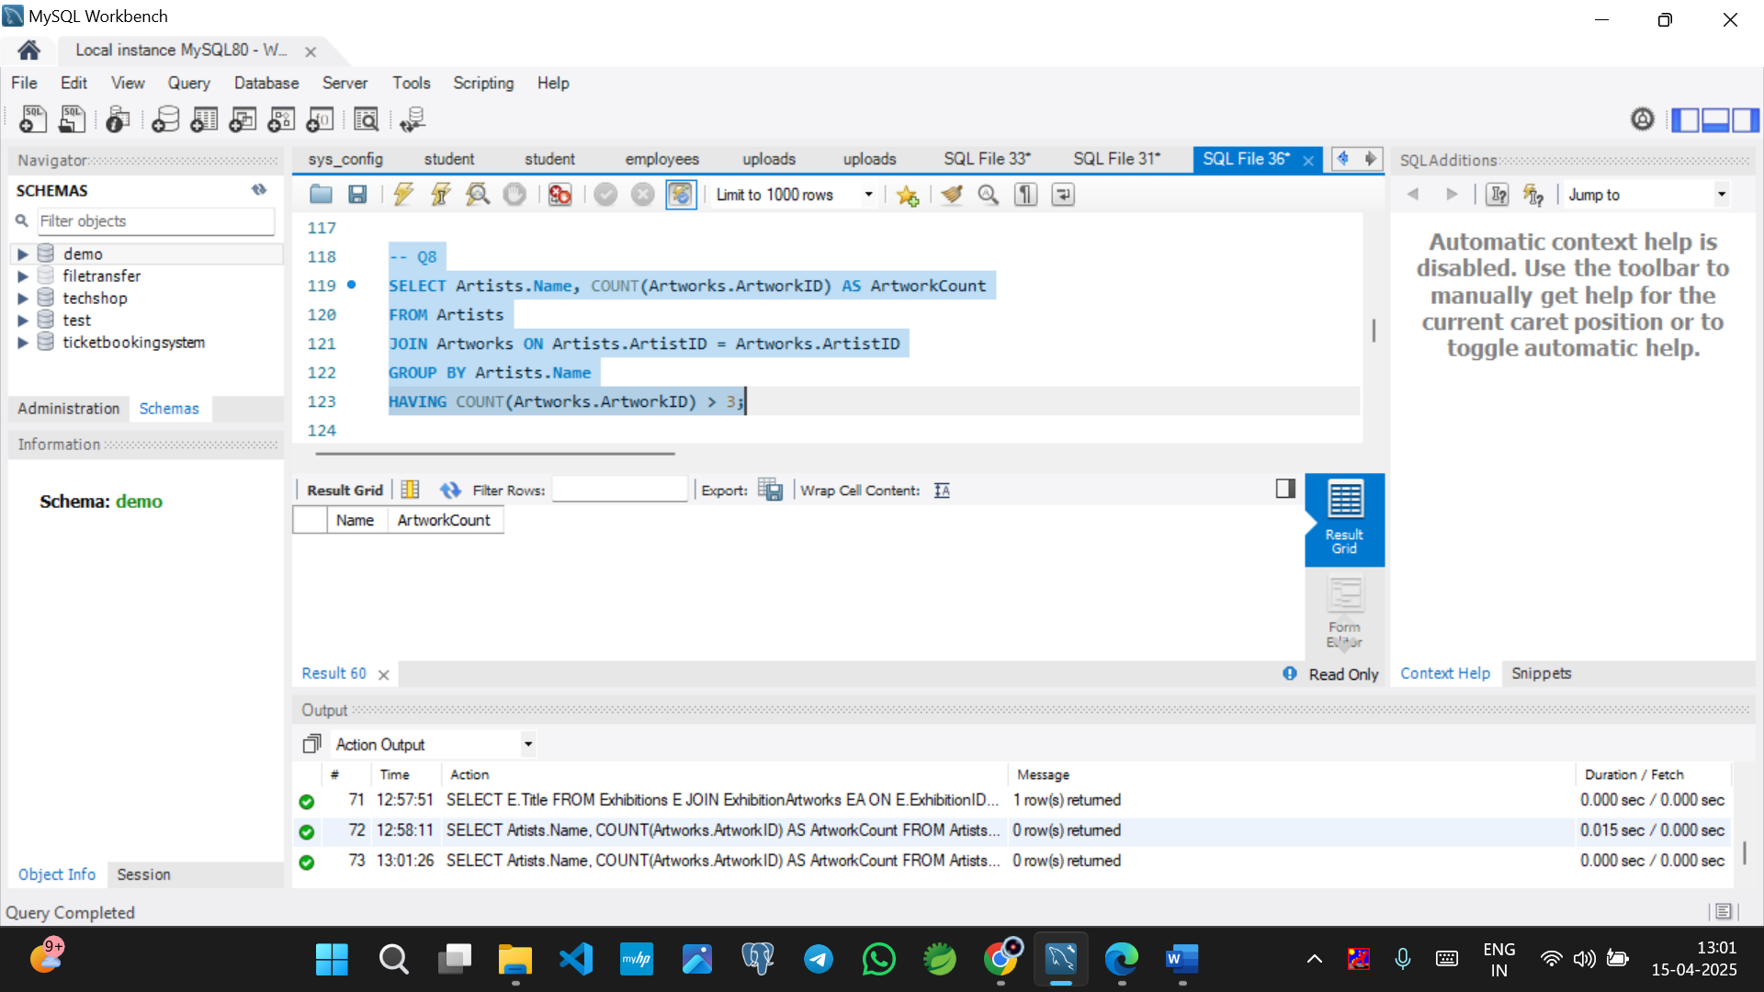

Q9

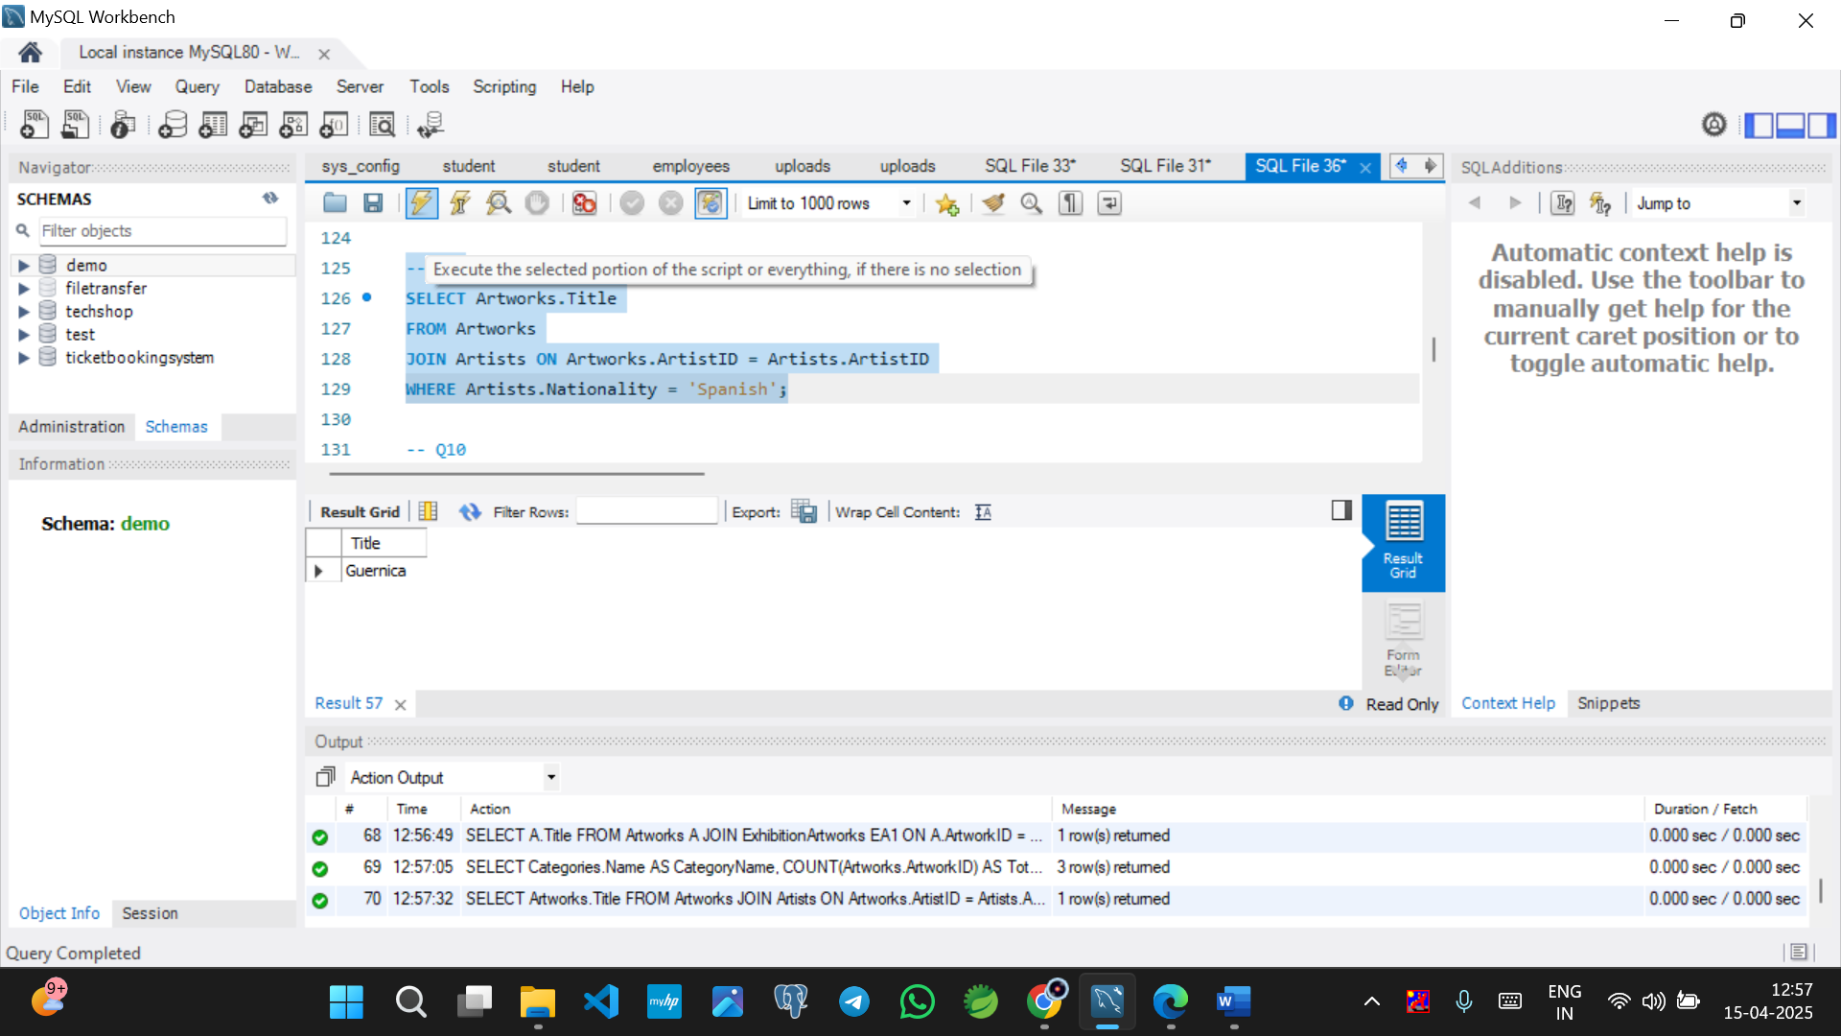

Q10

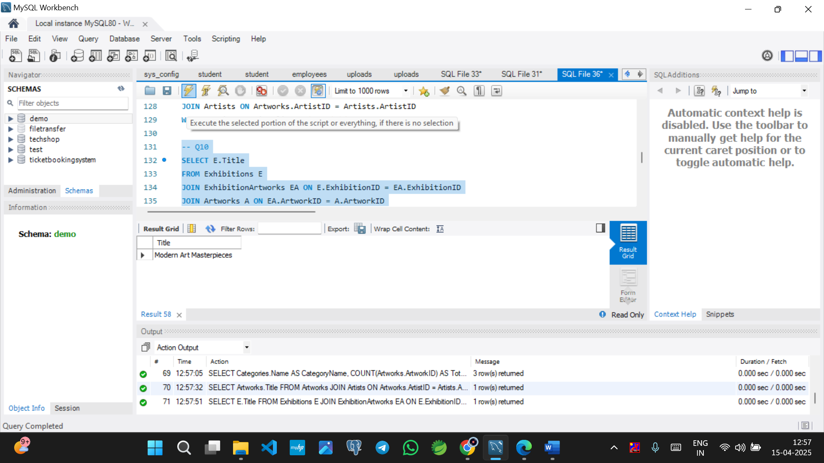

Q11

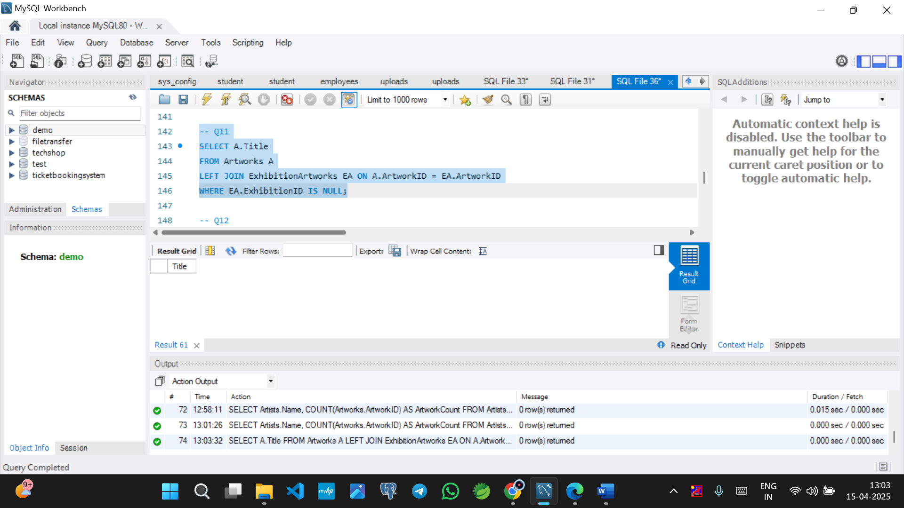

Q12

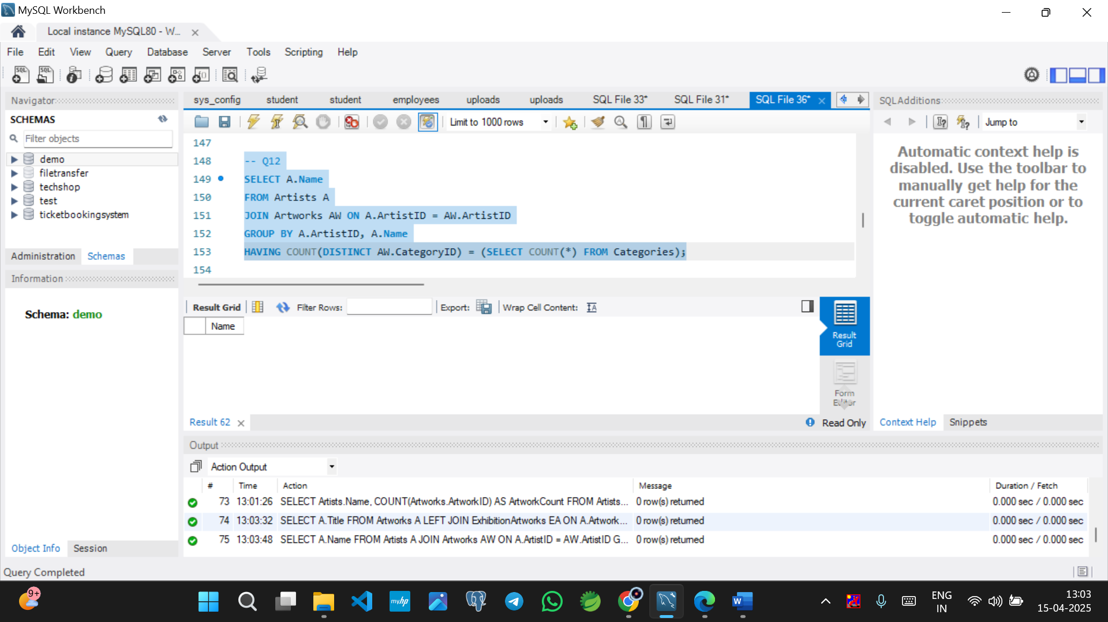

Q13

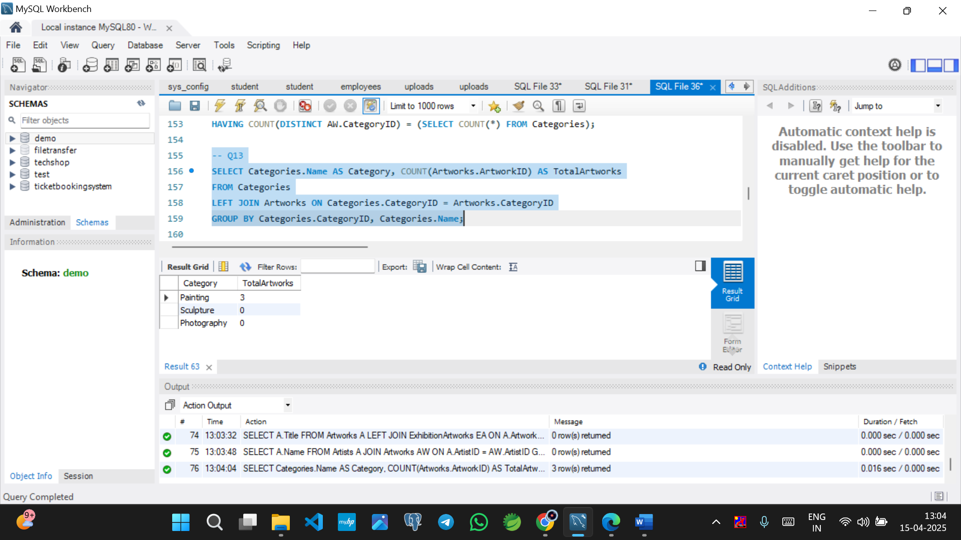

Q14

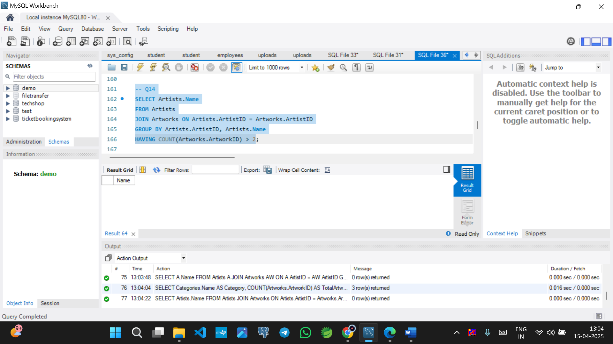

Q15

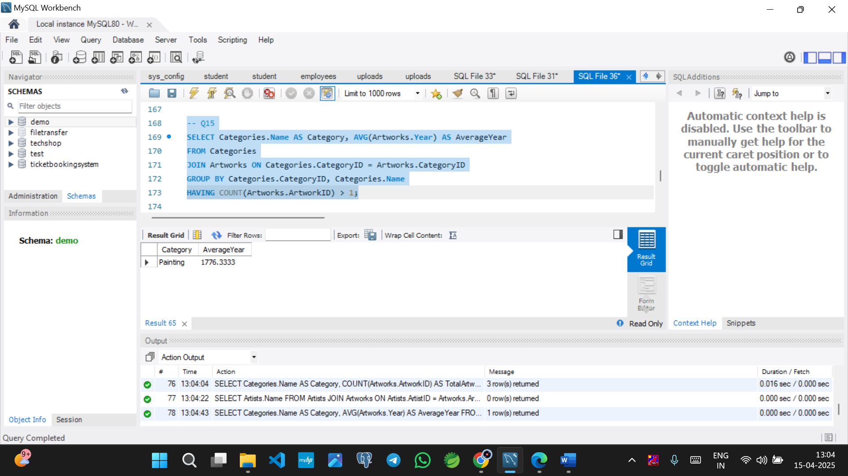

Q16

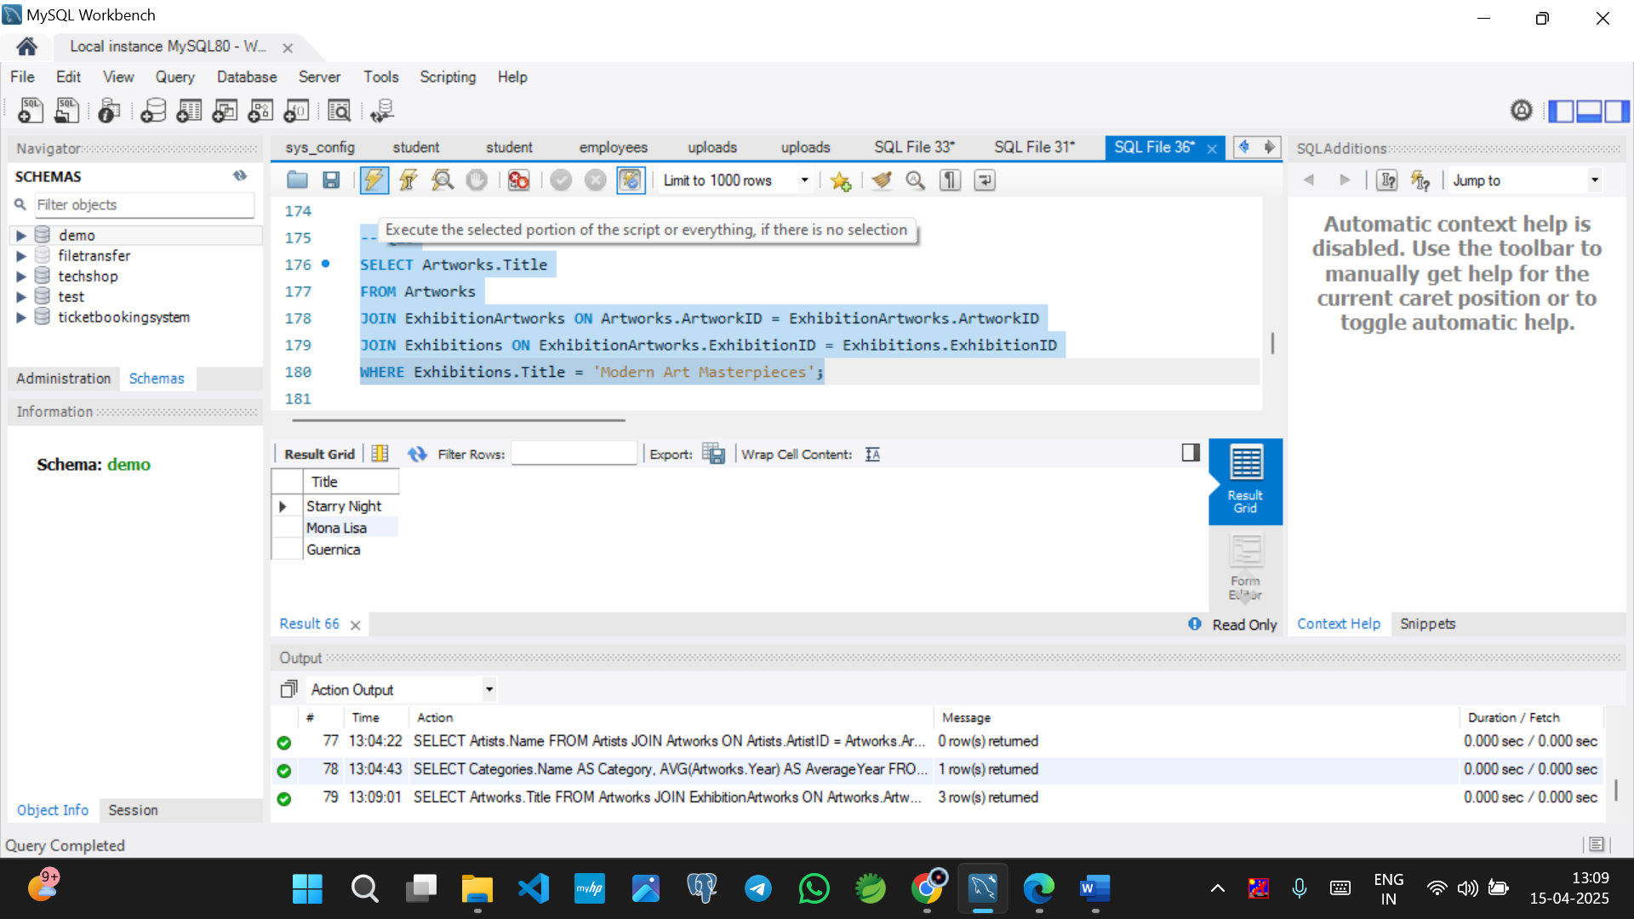

Q17

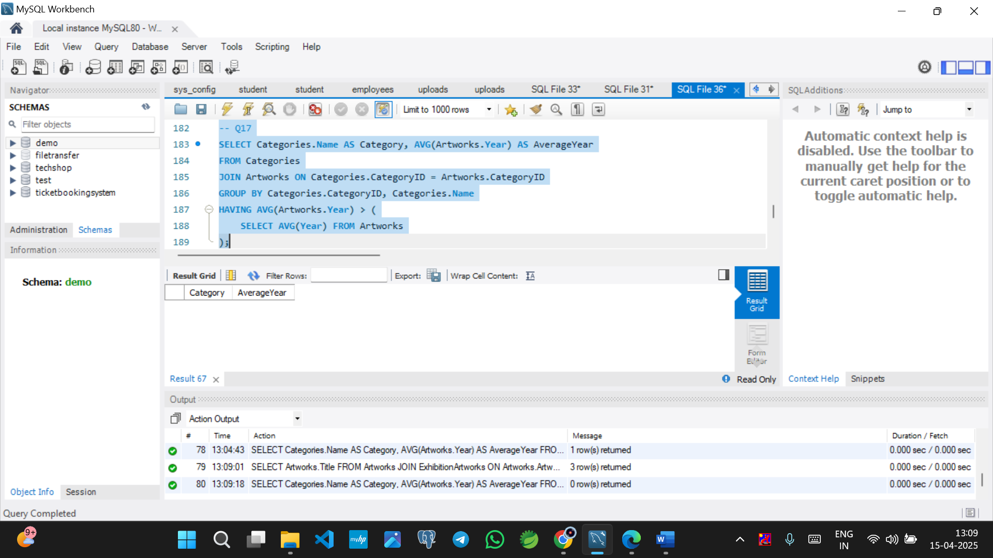

Q18

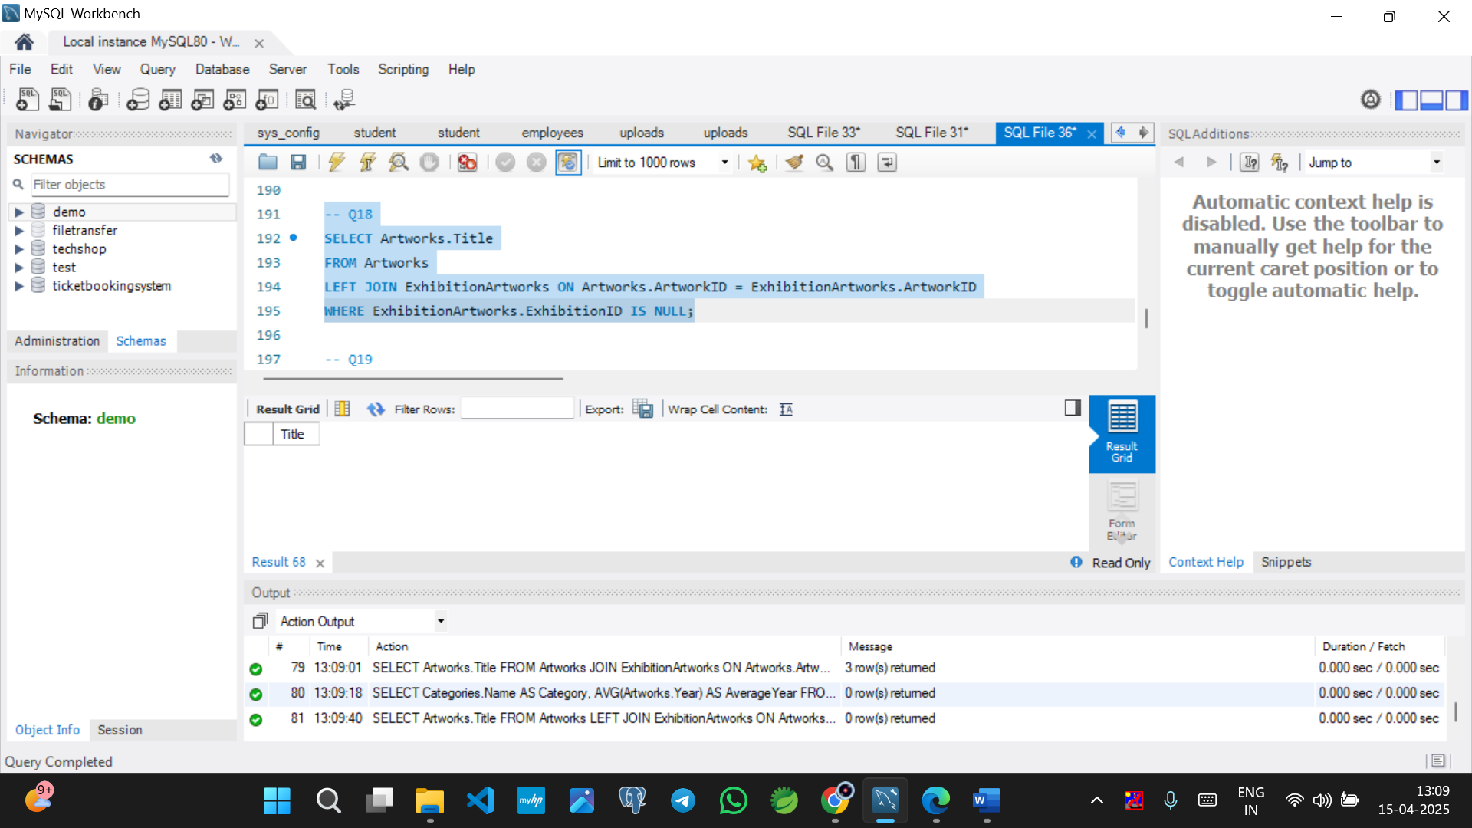

Q19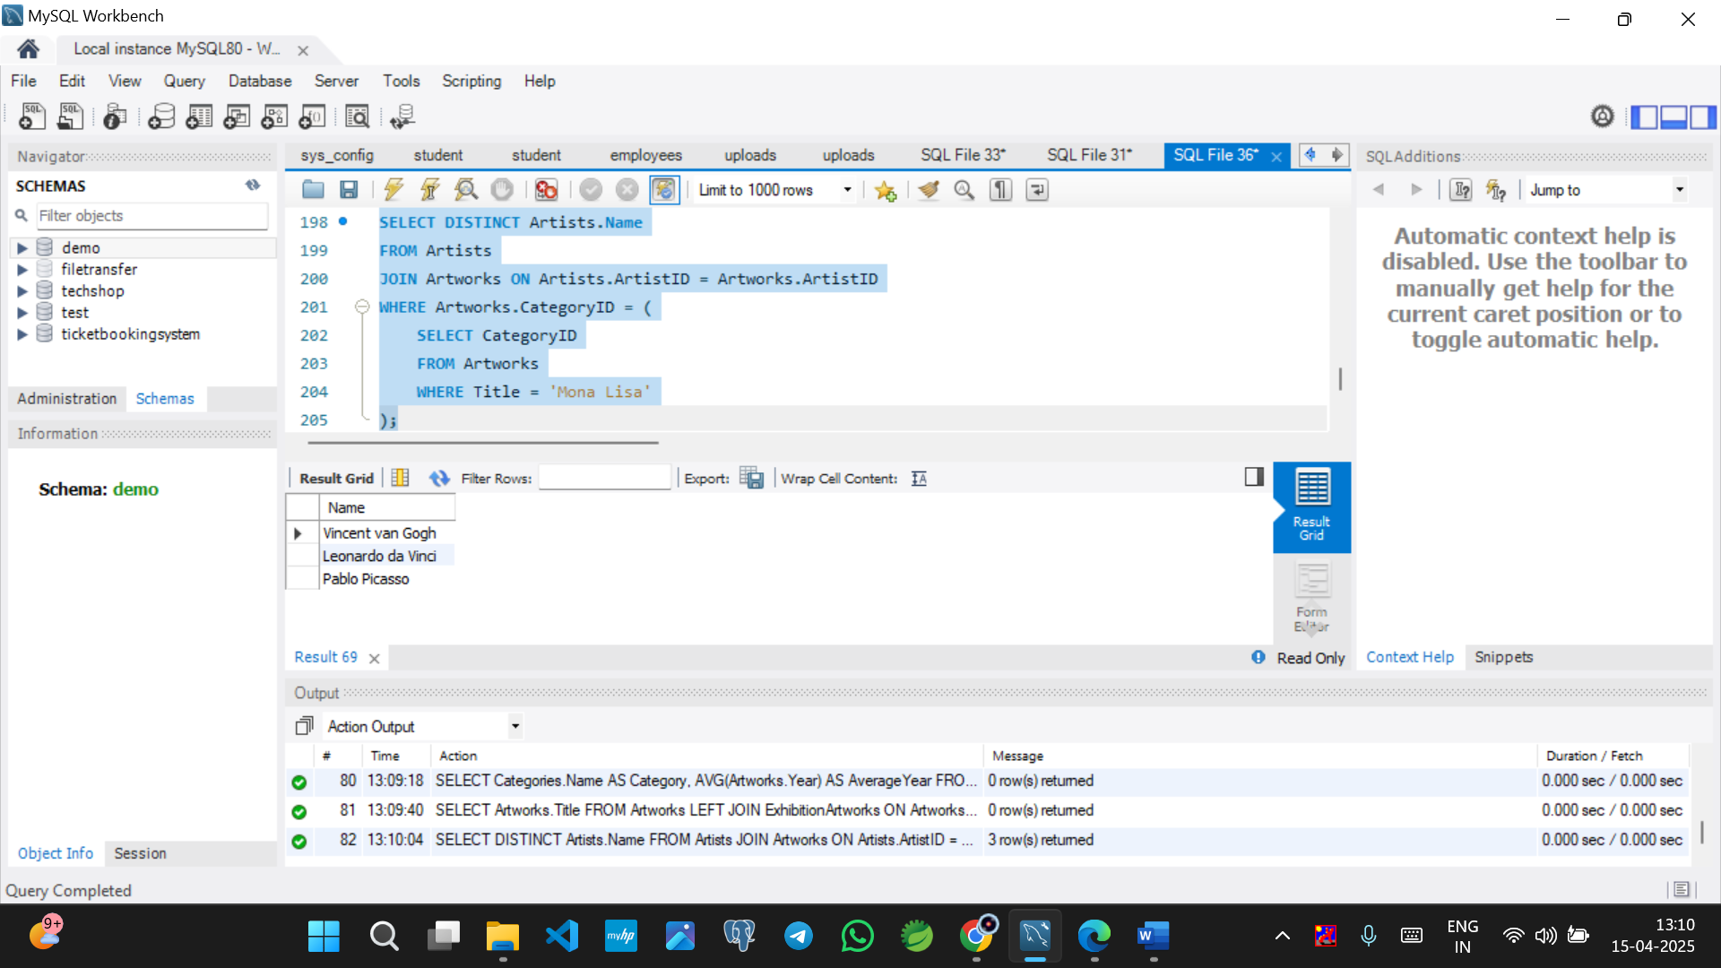

Q20

